**Exp.3 Ultrasonic sensor interface- obstacle detector and distance measurement**

CIRCUIT DIAGRAM:

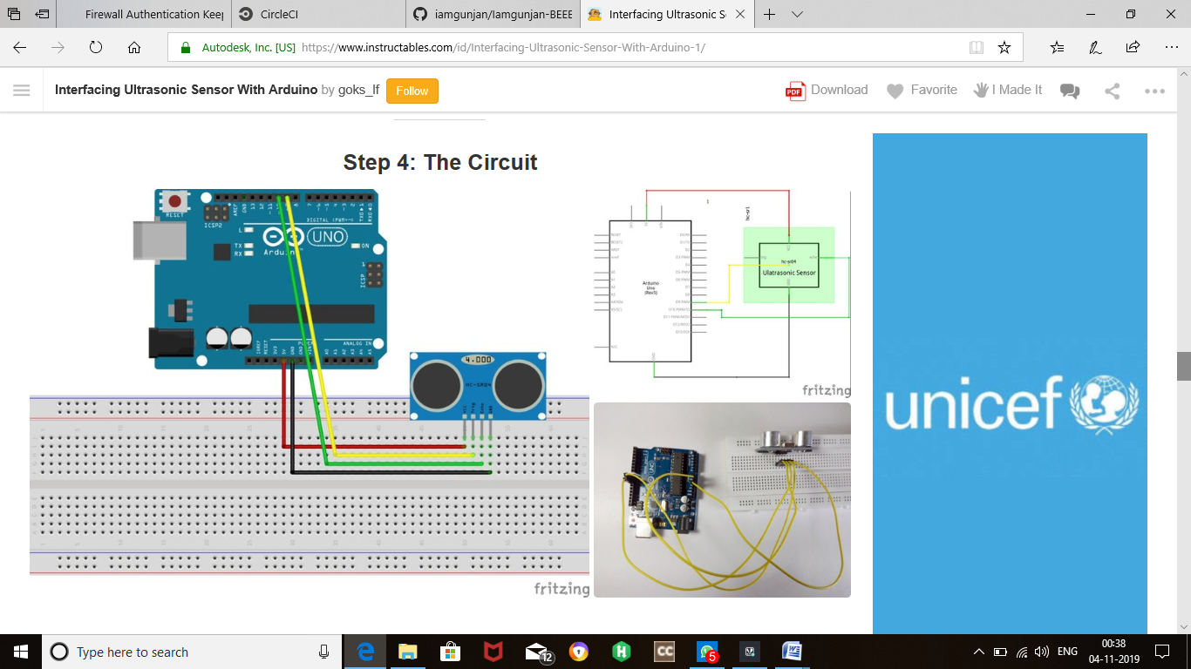

CONCEPT USED:

An Ultrasonic Sensor is a device that measures distance to an object using **Sound Waves**. It works by sending out a sound wave at ultrasonic frequency and waits for it to bounce back from the object. Then, the time delay between transmission of sound and receiving of the sound is used to calculate the distance.

It is done using the formula **Distance = (Speed of sound * Time delay) / 2**

We divide the distance formula by 2 because the sound waves travel a round trip i.e from the sensor and back to the sensor which doubles the actual distance.

CODE:

const int trigPin = 9;

const int echoPin = 10;

long duration;

int distance;

void setup() {

pinMode(trigPin, OUTPUT);

pinMode(echoPin, INPUT);

Serial.begin(9600);

}

void loop() {

digitalWrite(trigPin, LOW);

delayMicroseconds(2);

digitalWrite(trigPin, HIGH);

delayMicroseconds(10);

digitalWrite(trigPin, LOW);

duration = pulseIn(echoPin, HIGH);

distance= duration*0.034/2;

Serial.print("Distance: ");

Serial.println(distance);

}

Learning and Observations:

In this experiment we learnt the following:

1. Basic circuit building with Arduino uno.

2. Interfacing an ultrasonic sensor with Arduino uno.

Precaution:

1. The LED should not be connected in reversed direction because it doesn’t allow passing the current and circuit does not completed and LED will not glow.

2. The connections should be tight.

Learning Outcomes:

Via this activity we learn and acquire the skills about the following:

1. The application and usage of digital input/output pins of Arduino uno.

2. How ultrasonic sensor work and their interfacing with Arduino Uno.

3. Understood the syntax to write the basic code in Arduino IDE.

4. How to Identify the P-N Junction of LED.